Commerce in Hungary and in Europe

In my project, I would like to introduce the possibilities of the Hungarian corporations through CBA Ltd. I have chosen this firm, because I think this is one of the biggest in our country. It keeps stores nearly every city, and its ambition is make international business. For my project, I was able to use my experiences, because there are CBA shops near to my home place, where I usually shop.
In 1989, the government started the privatization process of state owned firms. The KÖZERT Corporation was one of them.

The history of CBA Ltd.

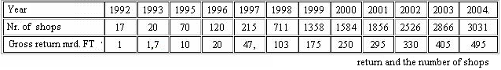
CBA was founded in 1992, when 10 storekeepers made an alliance, and they bought 17 stores from the KÖZERT Corporation. They made an effort from the start to be 100% of Hungarian property. The firm has grown dynamically, so nowadays, in less than 14 years there are 55 proprietors, and the number of shops has increased widely, so from the original 17, it has grown to 3031. In these days it is a nationwide network, which covers the whole country. This retail activity needed distributors, so they have created 22 regional centres, which are separate limited or public companies. The regional centres cover nearly the area of a county, but the geographical borders are not determinatives. To be a regional centre the precondition is to run warehouses, provide retail trade and supply them.

At first, they had a warehouse, with the floor space of 2000 m² , on Gyöngysor Street (1992). Later, they bought a new store house, on Nándorfejérvári Road, it had the floor space of 18000 m² (1998). The corporation opened a new logistic centre in the periphery of Alsónémedi, 25 km from Budapest, in 2005. The building has the floor space of 30000 m².
In these 14 years, the scope of shops has changed. At first, they had shops just in the area of Pest County, but nowadays, 80% of shops are in the countryside.
Foreign possibilities

Country | Number of shops | Company | Head Office
Hungary | 110 | CBA ltd. | Budapest
Slovenia | 150 | ERA | Velenje
Slovakia | 550 | M-MARKET | Losonc
Poland | 400 | NASZ-SKLEP | Reshow
Lithuania | 450 | CBA-AIBE | Vilnius
Croatia | 538 | CBA Zagreb | Zagreb
Romania | 650 | CBA Romania | Bucharest
Serbia and Montenegro | 170 | CBA SCG | Belgrade
Bulgaria | 115 | CBA Bulgaria | Sofia
Total: | 4123
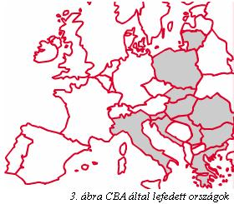
The biggest milestone in the history of CBA was to build a connection with EDEKA, (The EDEKA Group is the largest German supermarket corporation. Founded in 1898, it consists today of several cooperatives of independent supermarkets all operating under the name EDEKA ZENTRALE AG & Co KG, headquartered in Hamburg. There are approximately 4100 stores with the EDEKA nameplate that range from small corner stores to hypermarts in Germany.)
The cooperation has received further stimulus when Hungary joined the European Union.
In 2002, CBA initiated talks to open regional centres outside of Hungary, such as in Slovenia, Slovakia, Poland, Lithuania and Bulgaria. To get to know the cultures of other countries CBA holds national weeks when the products of a certain country is on sale. CBA uses different promotional techniques, like ads on television, on the internet, in the newspapers. The shops of the network operate in the franchise system, and their goal is, to create a uniform look everywhere in Europe. (logo, smock-frock…).
They started to sell their products, with their own brand, which are cheaper than other brands, but the quality is as good as the others. The firm and the executives, push to sell Hungarian products, because it is very important for them, to support Hungarian manufacturers.
The difficulties

The lack of skilled labour pushed forced CBA to contribute to local education and to set up its own qualification system, where students can learn about the business, and the management in general. They would expand this system for foreign countries.

Plans and facts

In 2001, they founded a consultation commission, including members from 8 countries, and their goal is to protect the manufacturers and storekeepers. The company is involved in charity activities, and donates money to hospitals or other foundations.
Once a year in May they organize a party for CBA workers and the public. They invite performers and they draw valuable prizes can be won in drawings.

I think it is would be very important for Hungary to have national companies, which represent our country, in other countries and in Europe.

Resources:
- A CBA Kereskedelmi Kft. szervezői nézőpontból: A franchise rendszer bevezetésének lehetőségei
Authors: Kakuk Szabolcs, Kátai Zoltán, Krajcsó Árpád
- Network magazine
- World economy
- Weekly World economy

