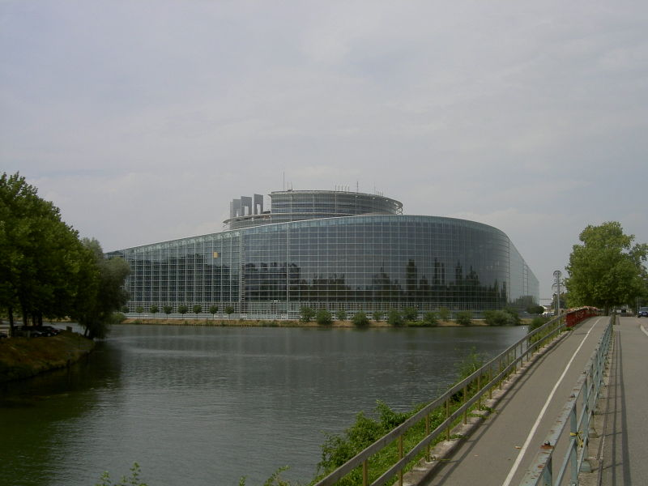

Hungarian investments outside the borders

Although the situation of small entrepreneurs in Hungary is not favourable enough to be able to open up towards foreign countries, greater enterprises have a relatively stable position in the country, so they can invest their money outside Hungarian borders. It became necessary by now, because these companies have almost outgrew the Hungarian market. Until now, it was more frequent that foreign countries invested their money in Hungary, but nowadays Hungarians also find their account outside the country.
In latter years the South-East European territory became more stable economically and politically, and so thus more attractive for foreign investors. There is a reason why this territory has a great advantage over other parts of Europe. The reason is that, there is still a kind of economic transformation in the countries of this region, and the process of privatisation is not yet finished. In the last few years, a lot of state-owned company had been transferred to private ownership, but all the same there are still many of them before privatisation. The other reason is that these countries are the neighbours of Hungary, and it means less hazard for Hungarian investors. Beyond that in this region there is a great economic advancement that means also a growth in the market. On the whole, it could bring more benefit for Hungarian entrepreneurs than the domestic market.

One of these countries, which belong to our sphere of interest is Romania, where the labour is more cheaper, and less fund is needed to set up a company. Until Romania joins the European Union our goal is to achieve a situation in which our country has almost the same role in the life of Romania than Austria had in the Hungarian economy. A company, named TriGránit is planning to invest 1 milliard euros in Romania, according to their conceptions, a big shopping centre will open soon in Kolozsvár.
Greater Hungarian companies started their intensive expansion in 2001, not only in Romania, but also in Bulgaria, Croatia and Macedonia. These investments, thanks to the great economic development and flattering economic milieu became more and more important. First, the MOL, which is one of the biggest oil companies in Hungary, bought a share in the Slovakian Slovnaft. Then the MATÁV bought up the Macedonian phone company. With this step, Hungary is still one of the biggest investors in Macedonia. In 2003 the OTP Bank purchased the Bulgarian merchant bank, then MOL gained a share in a Croatian oil company. The last two investments cost almost 800 million euros. In 2004 OTP bought the Romanian RoBank and also the Croatian Nova Banka. 2005 was the year, when the MOL extended its share in Croatia.
The case of the OTP shows how profitable is that kind of expansion for Hungary. The bank also opens up to Serbia, and it has branch banks in Slovakia, Bulgaria, Croatia and Romania. Besides these investments Hungary’s economic relation with France and the United Kingdom is also important.

All the same that France is one of the most outstanding investors in Hungary, in fact it is true that Hungarian entrepreneurs are still uncertain when a business is about French opportunities and when there is a chance to build up partnerships with French companies. The main reason for that is the difficulty of French language. Unfortunately in Hungary, not so much people speaks French. Besides, the other reason can be the differing mentality of the two countries.
Even so for today French market became the third most important target of export for Hungary. In latter years, especially after Hungary joined the European Union, France offers a lot of promising possibility in economic field. Before Hungary became the member of the Union there were a lot of administrative problems, it was not a really good thing because that is why France avoided import from Hungary. Now, this problem no more obstructs our relations with them. They usually look for wood, furniture, different instruments, and plastic products in Hungary. According to surveys there are still significant possibilities on the French market, unlike in other countries. Cooperation is also very important in „Health-industry” and different medical things, researches, that’s why Hungary aims to establish partnerships in the interest of common research programs and producing modern medical instruments. Hungarian products performed with success even on the very „critical” English market.
Our country gained a very important commercial partner in 2004, which is China.

As Hungarian spheres of interests matched Chinese conceptions, companies reacted really positively for Hungarian initiations, therefore our country could be the centre of their Central-European plans. As a result, the Hainan Airlines in cooperation with the Hungarian Malév started a flight between Budapest and Peking, and besides the Hisense Television Company was also found in Hungary, which belongs to the Chinese Huawei company. This bilateral partnership includes chiefly electronical things, car spare parts and informational technology.
On the whole, Hungary will enjoy the benefits of its membership in the European Union on the field of economy too. As there are no more frontiers between us and the neighbouring countries, a continuous transport of products can be achieved and we can make good connections with other countries. On the other hand the Hungarian capital has really good capabilities and thus can become the main commercial gate of the Balkans and Eastern-Europe to western territories.

