The OTP Bank’s Foreign Expansion

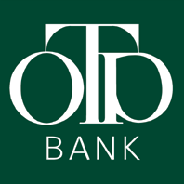

What does this acronym mean?
Nationwide – Providence – Chest

- Available in the whole country
- Prompts you to thrift, or gives you the opportunity to make some savings
- A point where you can pay in and get paid out

Our family had chosen – like the most of the people in the country – this bank, when we wanted to have our money in a safe place, and when we needed some credit.
Then, by the opening of an account we made our financial transactions a lot easier. My parents got a bank card, and accepted the bank's retirement savings plan.
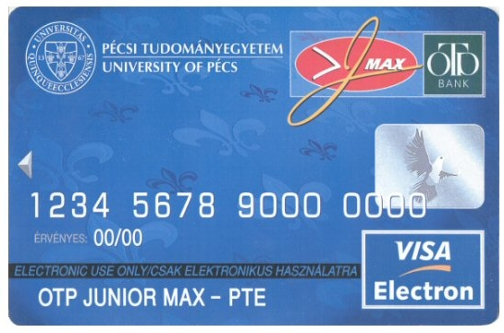
The OTP is a part of our life. Last autumn, when I started my studies at the University
of Pécs, I chose the OTP also, and made
an account. I haven't thought, that I will
look into the details of the way how the
public company works.
This competition made me to get to know of the background processes that are standing behind the spreading of Hungary's biggest financial corporation.

Hungary's biggest bank is the OPT Bank, which had to spread over the country border in the last 10 years because the society's and economy's structural variation. Within the international tendencies show faster enlargement in the monetary services. Hungary has to prepare for a stronger race in the solid market, because the European Union's liberalisation makes a bigger race in the supplies market. This can be partly solved with a partner from a country of the EU. The conditioning in the bank sphere is very tough, all of the countries are trying to harmonise the rules in there too. If the OTP Bank wants to survive in this competition, it has to make its foreign relationships stronger.

The past:
National Savings and Commercial Bank Ltd. (the “Bank” or “OTP”) was established on December 31, 1990, when the predecessor State-owned company was transformed into a limited liability company.
Subsequent to the successful initial public offering in summer 1995, the Bank's shares were introduced to the Budapest and the Luxembourg stock exchanges and were also listed on SEAQ London and PORTAL (USA).
By public offerings in fall 1997 and fall 1999, the State Privatization and Holding Company sold the remaining common shares.
The Annual General Meeting on April 25, 2001 approved the conversion of HUF 1,150 million nominal value preference shares issued by the Bank to common shares. In the first quarter of the year of 2002 the nominal value of the common shares of the Bank decreased from HUF 1,000 to HUF 100 per share.

The present:
As at December 31, 2004 approximately 90.3% of the Bank’s shares were held by domestic and foreign private and institutional investors. The remaining shares are owned by employees (3.3%) and the Bank (6.4%). The Bank provides a full range of commercial banking services through a nationwide network of 377 branches in Hungary. As at December 31, 2004 the number of employees at the Bank was 7,894. The average number of employees for the year ended December 31, 2004 was 7,974.
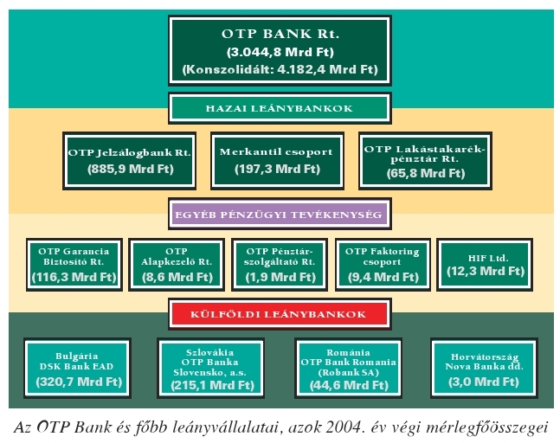
The OTP Bank Rt. is a people oriented universal bank is Hungary's leading monetary supplier and has a big roll in the Centre- Eastern- European market with its subsidiaries.
The Bankgroup has a leading position in the Hungarian public market, took care of 29% of the family deposits and more than 40% of the credits on the 31st 2004. The Bankgroup has more than 3 million charge accounts and leader in the bank card issue and the electronic supplies. It is the determinative in the contractor and government class. The OTP Bank's strongness is in the multilined selling network: it has more than 400 banks, 1400 ATMs, and the clients can contact them through the internet and phone. It has subsidiaries in Bulgaria, Slovakia, Romania and Croatia.

Foreign Subsidiaries

DSK BANK EAD
DSK Bank achieved major successes in its first full financial year as a member of the OTP group. After-tax profit totalled HUF 9.0 billion in 2004, which represents an increase of 51.1% compared to 2003. At the end of the year the Bulgarian subsidiary had achieved ROAA of 2.44% and ROAE of 19.2%.
DSK Bank’s balance sheet total stood at more than HUF 409 billion on December 31, 2004, or 26.7% higher than at the end of the previous year, and its equity was HUF 50.5 billion (an 17.3% rise). The bank’s loan and deposit portfolios grew by 62.7% and 21.6% respectively, with the volume of loans totalling HUF 274.1 and deposits HUF 331.3 billion by the end of the year. In 2004 DSK Bank became market-leader in terms of total business volume, in respect of both deposits and loans. Despite this, the bank’s market share in terms of balance sheet total fell from 13.8% at the end of 2003 to 13.1% by the end of 2004, partly due to the withdrawal of a number of state deposits at the end of the year, and partly to the temporary placement of certain privatisation revenues at another bank.
Based on its balance sheet total, at the end of 2004 DSK Bank was the second largest financial institution in the Bulgarian banking sector. The bank expanded its range of retail banking products considerably, launching no less than 20 new or revamped products during the year. These included a credit card, a student card, a foreign currency account, long-term deposits, consumer loans, a savings account with tiered interest rates, new electronic services and the customer terminal. At the end of 2004, DSK Bank was serving customers through a network of more than 320 branches. The number of retail bankcards issued by the bank stood at 692,000 at year-end, which equates to an increase of close to 53% compared to the end of 2003. The number of ATMs rose by 44%, and the number of POS terminals by 76%, to 351 and 462 respectively by the end of the year.
The number of employees at DSK Bank fell by 300, or 8%, over the year. With the assistance of OTP Bank, continuous and intensive marketing campaigns have been launched to promote the bank’s new products and to support the change in its image. In the interests of building an integrated financial group, DSK Bank, jointly with OTP Garancia Insurance, established one life and one non-life insurance company in Bulgaria. The life insurance company (DSK Garancia Life AD) began its operations in September, while the non-life insurance company is currently in the process of obtaining its operating licences from the Bulgarian supervisory authority. In early 2005, DSK Bank acquired a 66% stake in DSK Asset Management AD, founded by OTP Fund Management Ltd. Besides establishing these companies, the bank sold its minority stake in Bulstrad DSK Life AD and raised the capital of DSK Rodina AD by BGN 1 million.

OTP BANKA SLOVENSKO, A.S.
The Slovakian bank’s balance sheet totalled HUF 215.1 billion at the end of 2004, which represents an increase of 34.5% compared to the end of 2003, and gave the bank a 2.8% share of the Slovakian banking market. The bank’s equity rose over the same period by 1.4%, to HUF 14.2 billion. OBS’s after-tax result for 2004, according to Hungarian accounting standards, was a loss of HUF 57 million, which was an improvement over the previous year’s loss of HUF 207 million. The bank’s ROAA at the end of 2004 was minus 0.03%, and its ROAE was minus 0.4%. OBS achieved an after-tax profit according to Slovak accounting standards of HUF 522 million in 2004.
In 2004 OBS launched several new products on the Slovakian banking market. Among them was the Solvent Biznis Card, a product similar to the Széchenyi Card, which it issues to corporate customers, and also in 2004 it introduced the Europackage, a savings account, and various sub-account products, as well as a structured offer for home owner associations.
In 2004 both mortgage lending and consumer lending expanded dynamically, with total retail loans amounting to HUF 26.7 billion at the end of the year. Growth in corporate and municipality lending was similarly robust and at the end of the year the commercial banking portfolio stood at HUF 115.9 billion. The bank’s deposit portfolio reached HUF 139.9 billion at the end of 2004, which represents a growth of 25%. During the course of 2004 the number of the bank’s customers increased by over 9,000 to more than 156,000, of whom more than 139,000 were retail customers. The number of bankcards issued by OBS had exceeded 100,000 by the end of 2004, which represents an increase of 16% compared to the end of 2003. This total was made up of nearly 91,000 retail and 9,600 corporate bankcards. The bank’s network of ATMs numbered 102 units at the end of the year, and these were used to perform some 1.6 million transactions, a 13% increase over 2003. The number of proprietary POS terminals at the end of 2004 was 479, and the volume of POS transactions increased by 120% over the course of the year. OBS opened 8 new branches during the year, bringing the total number of branches in its network to 68 at the end of 2004.

ROBANK SA
Robank and its subsidiary, Robinv SA, were officially acquired by OTP Bank (99.99%) and its subsidiaries (0.01%) on 30 July 2004. Following the acquisition, OTP Bank increased the company’s capital by EUR 10 million, almost doubling it to HUF 5.3 billion.
As part of the bank’s restructuring and change of corporate image, OTP Bank changed the company’s name to OTP Bank Romania SA at its shareholders’ meeting of February 15, 2005. The Romanian bank’s balance sheet total was HUF 44.6 billion at the end of 2004, which equates to a market share of 0.8%. Following its acquisition, the bank achieved an after-tax profit of HUF 52 million in 2004, and HUF 428 million for the whole year of 2004, and the ROAE for the whole year was 6.7% and ROAA was 1.1%. Robank’s loan portfolio was HUF 16 billion at the end of 2004, 98.5% of which are corporate placements, while the total volume of its deposits stood at HUF 28.7 billion, of which retail deposits accounted for almost half. The bank’s equity totalled HUF 7.7 billion at the end of 2004.

The Bank couldn't reach this profit with its business units only, without the foreign partnerships. The efficiency is very good, even in the international scene, the strategy pointed to the performance and the started upgrades both guarantee the leadership for the coming years.
The foreign expansion started as road they must walk to survive, but still it can be looked at as a result, which makes Hungary look as a better country in the EU.

Hosszúhetény 2006. 02. 13.
Várnagy Szabolcs

