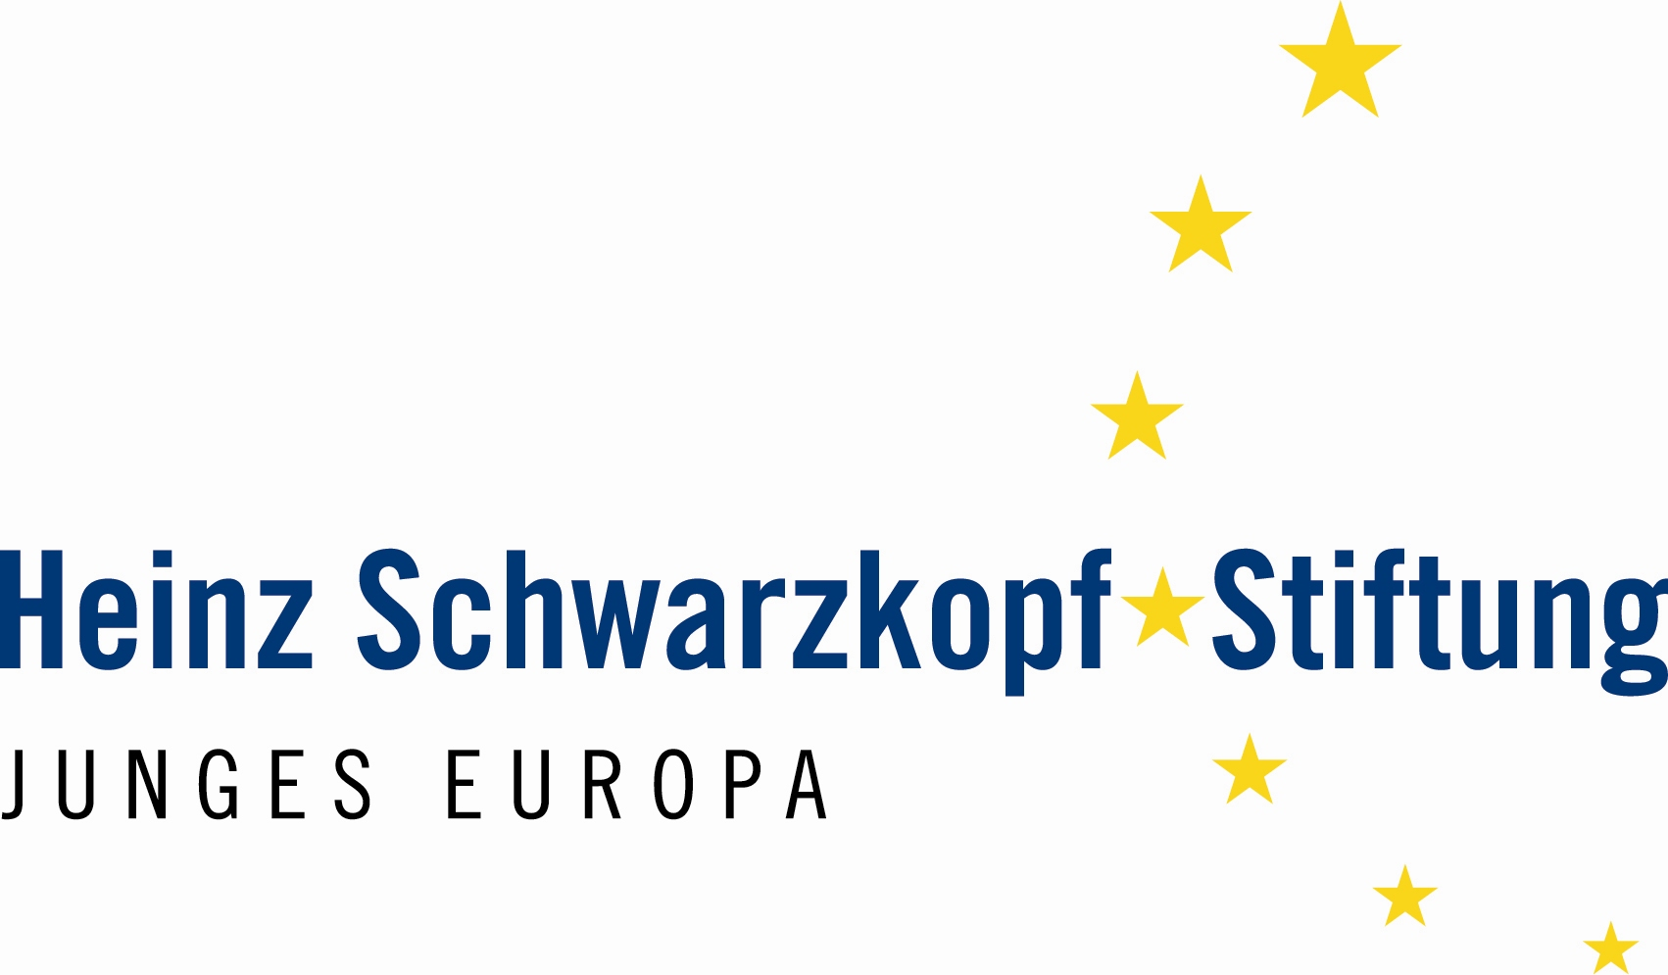



EURO-MEDITERRANEAN YOUTH PARLIAMENT

Berlin, 26.05.2007 – 03.06.2007
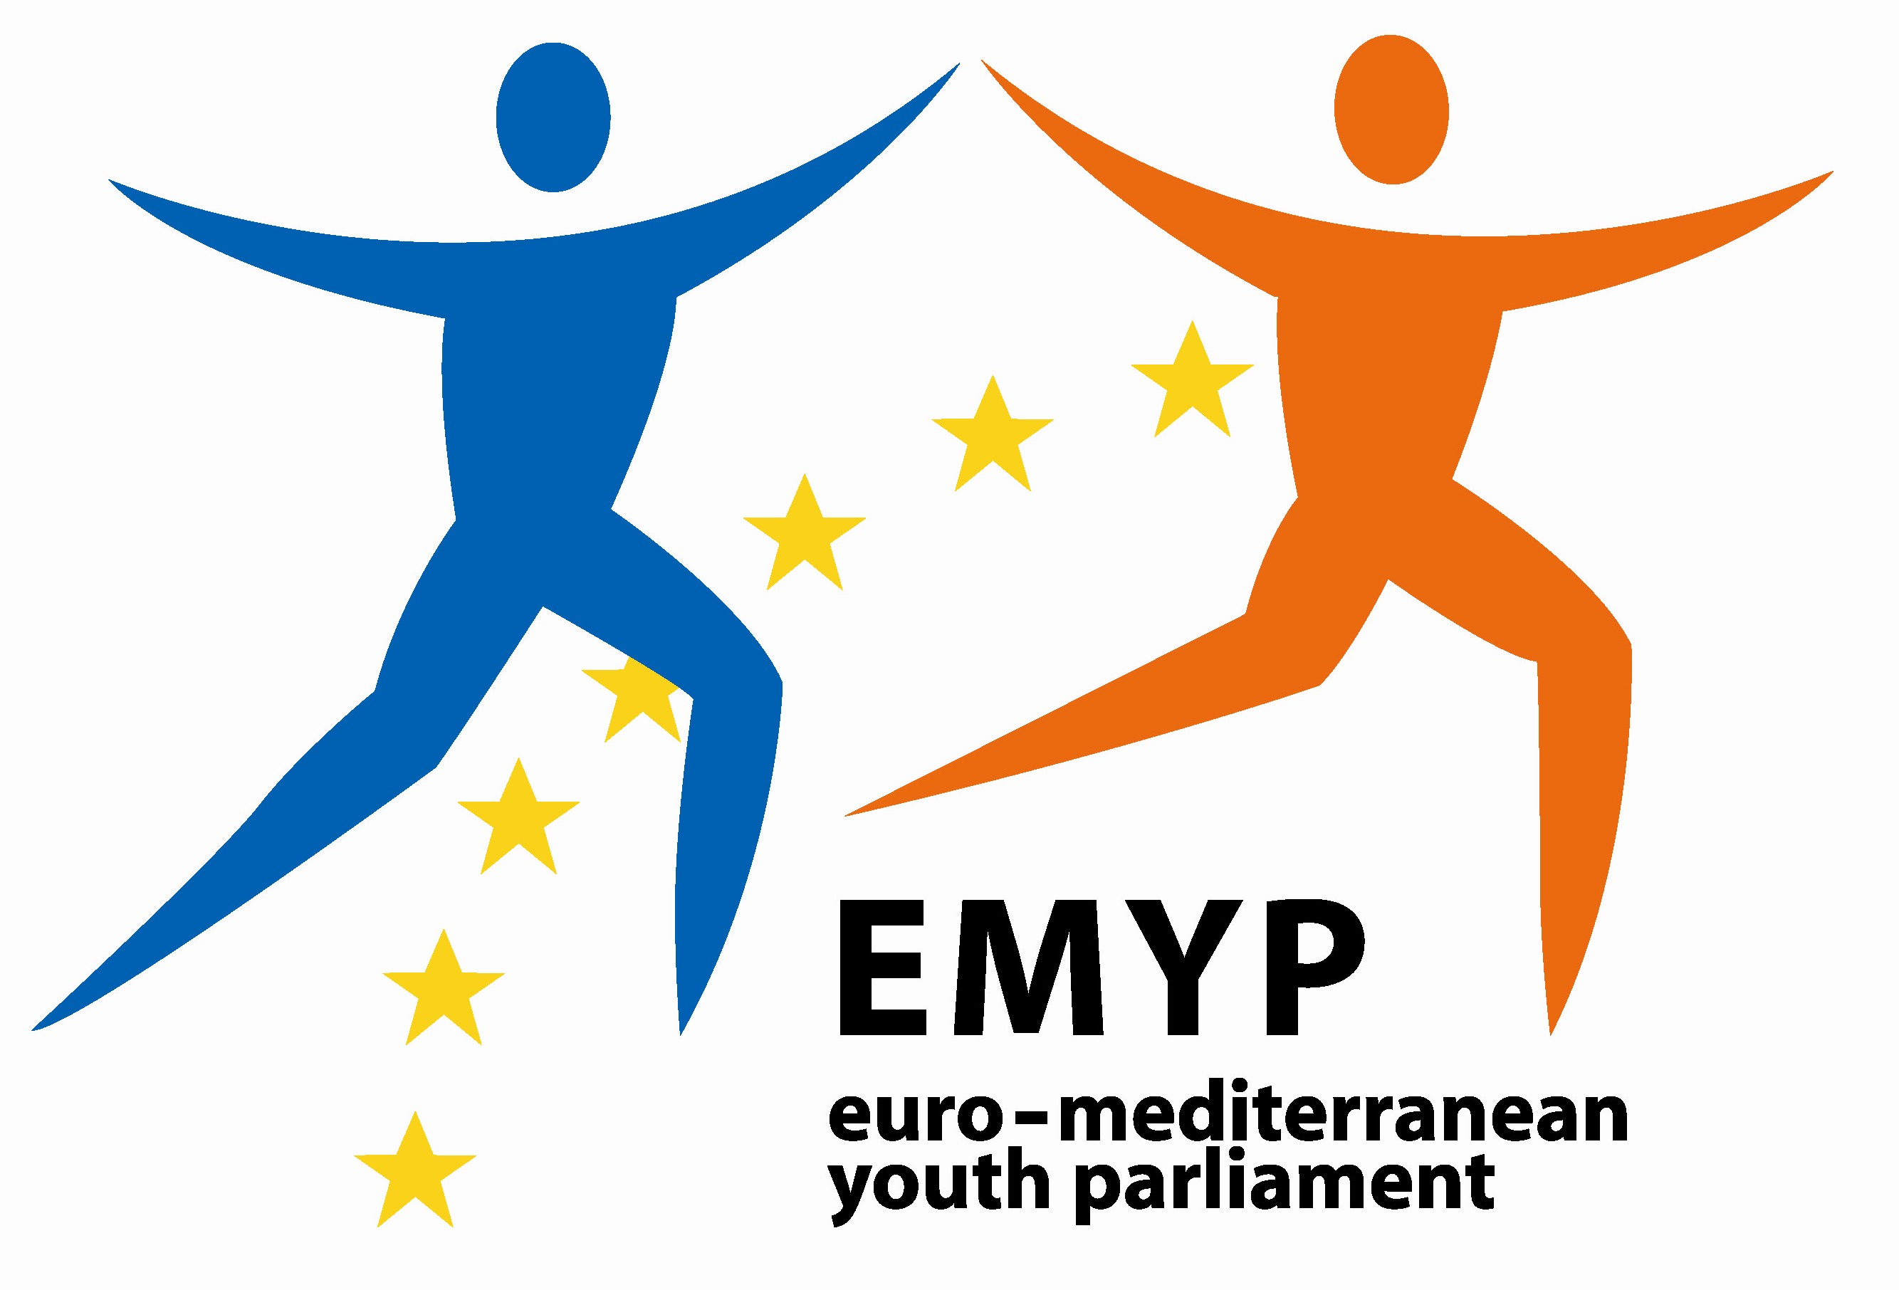

APPLICATION FORM

This form must be completed in English, written in Block Capitals
and sent to info@cairo.goethe.org AND youth-parliament@cairo.goethe.org
before 04 January 2007 at 12:00 noon (GMT)

I- Information on the Applicant

Candidat/Applicant: M./Mr  Ms. ▢ Mr. ▢
Surname:
First Name:
Date and Place of Birth:
Nationality:
Marital status:
Home address:

Tel.: ....................…………………………….. Mobile:
E-mail:

II- Experience of the Applicant
a- Studies

Name of School or University | Dates | Diploma obtained | Main subjects

b- Work experience

Name of the institution | Dates | Position | Main responsibilities

c- Languages

I certify that my level of knowledge of English is:
Comprehension: ▢ Very good ▢ Good ▢ Average ▢ Basic
Speaking: ▢ Very good ▢ Good ▢ Average ▢ Basic
Other languages: …………………………………………………………………………………………………………

d- Other experiences:

Experience abroad (name of the countries):
…………………………………………………………………………………………………………………..
……………………………………………………………………………………………………………….....
…………………………………………………………………………………………………………………..
…………………………………………………………………………………………………………………..
…………………………………………………………………………………………………………………..
Have you already attended a Euro-Mediterranean youth activity?:
…………………………………………………………………………………………………………………..
……………………………………………………………………………………………………………….....
…………………………………………………………………………………………………………………..
…………………………………………………………………………………………………………………..
Have you ever been part of a Euro-Mediterranean project or initiative before? If yes, state it for us and describe your role:
…………………………………………………………………………………………………………………..
……………………………………………………………………………………………………………….....
…………………………………………………………………………………………………………………..
…………………………………………………………………………………………………………………..
…………………………………………………………………………………………………………………..
…………………………………………………………………………………………………………………..
…………………………………………………………………………………………………………………..

III- Motivations and expectations:

Explain your motivation in participating to this event:
…………………………………………………………………………………………………………………..
……………………………………………………………………………………………………………….....
…………………………………………………………………………………………………………………..
…………………………………………………………………………………………………………………..
…………………………………………………………………………………………………………………..
……………………………………………………………………………………………………………….....
…………………………………………………………………………………………………………………..
…………………………………………………………………………………………………………………..
…………………………………………………………………………………………………………………..
……………………………………………………………………………………………………………….....
…………………………………………………………………………………………………………………..
…………………………………………………………………………………………………………………..
What are your expectations?:
…………………………………………………………………………………………………………………..
……………………………………………………………………………………………………………….....
…………………………………………………………………………………………………………………..
…………………………………………………………………………………………………………………..
…………………………………………………………………………………………………………………..
……………………………………………………………………………………………………………….....
…………………………………………………………………………………………………………………..
…………………………………………………………………………………………………………………..
…………………………………………………………………………………………………………………..
How can you contribute to the Euro-Mediterranean Youth Parliament and to the sustainability of its action? (max. 100 words):
…………………………………………………………………………………………………………………..
……………………………………………………………………………………………………………….....
…………………………………………………………………………………………………………………..
…………………………………………………………………………………………………………………..
…………………………………………………………………………………………………………………..
……………………………………………………………………………………………………………….....
…………………………………………………………………………………………………………………..
…………………………………………………………………………………………………………………..
…………………………………………………………………………………………………………………..
……………………………………………………………………………………………………………….....
…………………………………………………………………………………………………………………..
…………………………………………………………………………………………………………………..
…………………………………………………………………………………………………………………..
……………………………………………………………………………………………………………….....

Please write a short essay (max. 300 words) answering the following questions:
In your opinion, what are the main challenges the Euro-Mediterranean region is currently facing and what are your proposal(s) for a better future?
In your opinion and within the Euro-Mediterranean context do you think that the Euro-Mediterranean Youth Parliament can have a significant role to play? If yes, what should this role be?
…………………………………………………………………………………………………………………..
……………………………………………………………………………………………………………….....
…………………………………………………………………………………………………………………..
…………………………………………………………………………………………………………………..
…………………………………………………………………………………………………………………..
……………………………………………………………………………………………………………….....
…………………………………………………………………………………………………………………..
…………………………………………………………………………………………………………………..
…………………………………………………………………………………………………………………..
……………………………………………………………………………………………………………….....
…………………………………………………………………………………………………………………..
…………………………………………………………………………………………………………………..
…………………………………………………………………………………………………………………..
……………………………………………………………………………………………………………….....
…………………………………………………………………………………………………………………..
…………………………………………………………………………………………………………………..
…………………………………………………………………………………………………………………..
…………………………………………………………………………………………………………………..
…………………………………………………………………………………………………………………..

Please notice that we reserve the right to invite the selected participants for a personal interview.

IV. Validation and Signature:

Date: ………………………………………………….
Signature: …………………………………………….

Name of two employers or recommenders: …………………………………………………………………
Contact of both: ……………………………………………………………………………………………………………………
……………………………………………………………………………………………………………………
……………………………………………………………………………………………………………………
……………………………………………………………………………………………………………………

