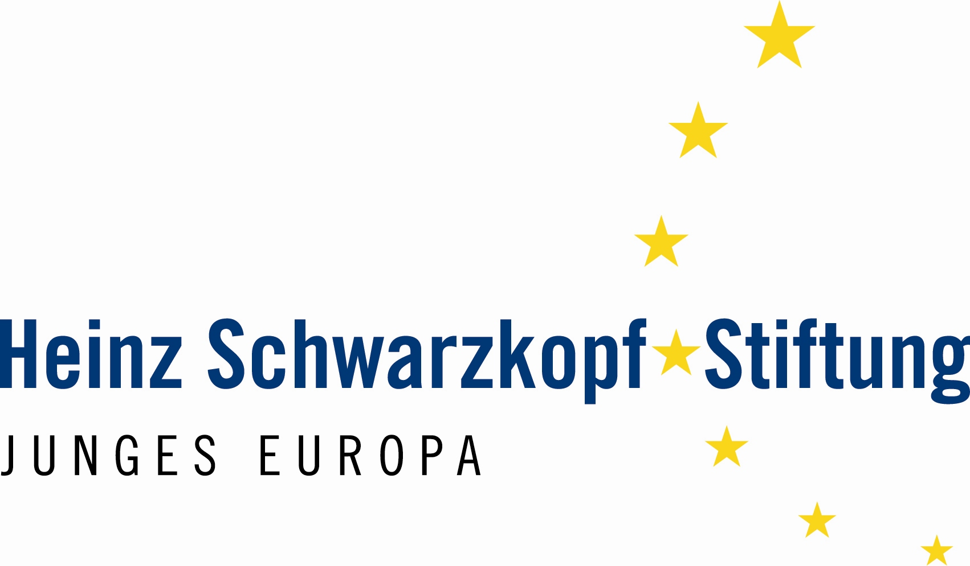
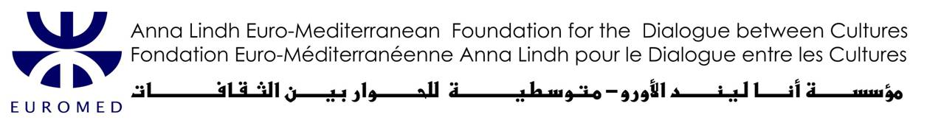
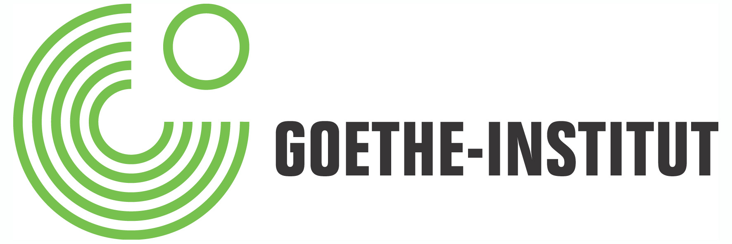

EURO-MEDITERRANEAN YOUTH PARLIAMENT

Berlin, 26.05.2007 – 03.06.2007
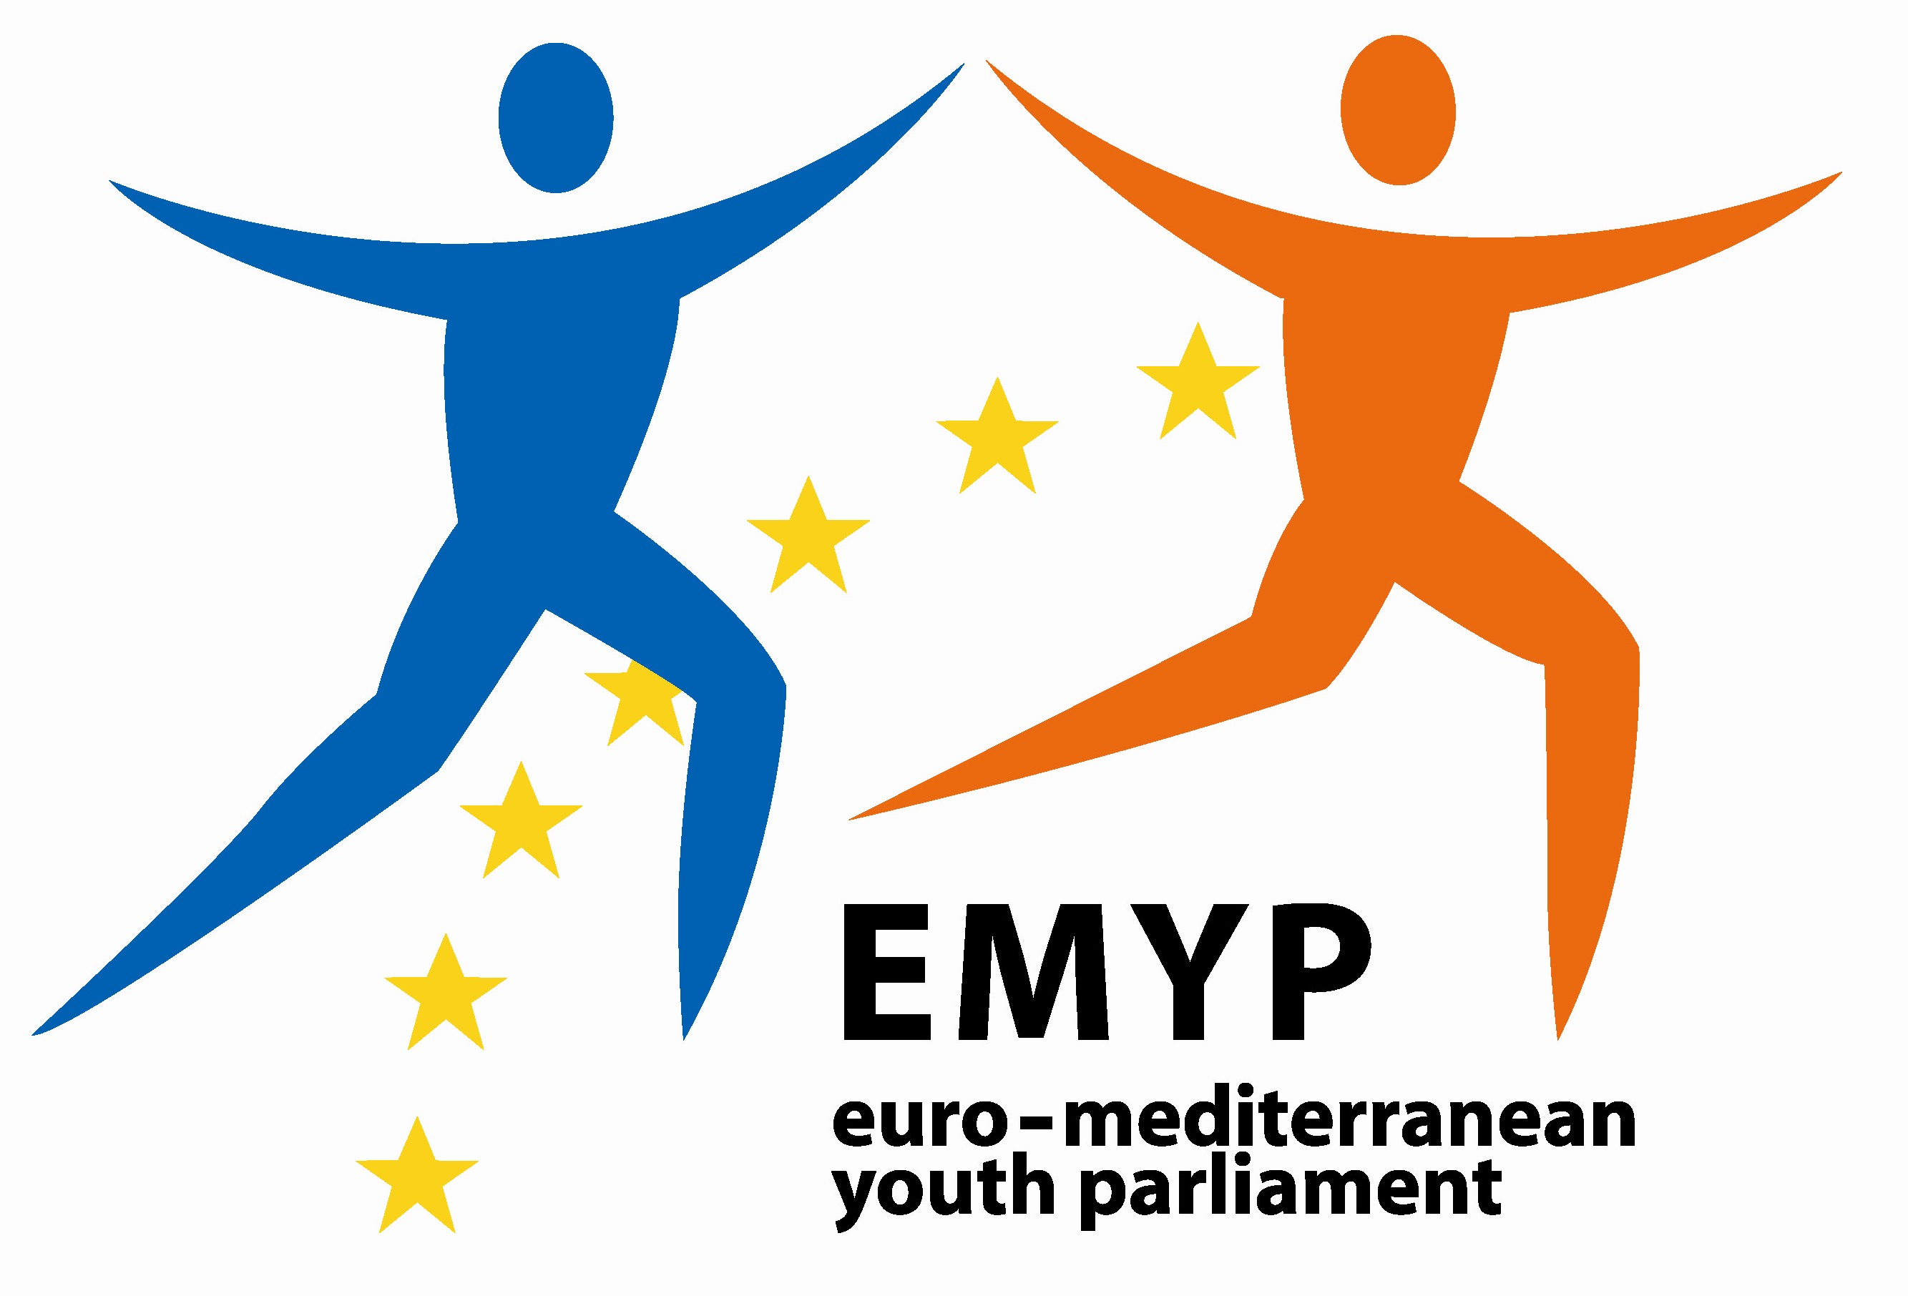

CALL FOR APPLICATIONS

- Participants of the Mediterranean Countries -

The German Federal Foreign Office, in co-operation with the EU Commission, invites young adults from Mediterranean and EU member states to participate in a “Euro-Mediterranean Youth Parliament” in Berlin from 26.05.2007 – 03.06.2007. The event is organised by the Goethe-Institut and the Heinz-Schwarzkopf-Stiftung, in close cooperation with Anna Lindh Euro-Mediterranean Foundation for the Dialogue between Cultures.

Preparatory Meeting in Alexandria for Mediterranean Participants (Feb. / March 2006)
For the selected participants from the Mediterranean countries there will be a preparatory meeting in Alexandria at the end of February or beginning of March 2007, as well as training courses by their local Goethe-Institutes which have to be completed in January and February 2007.

Objectives
The Barcelona Process launched in 1995 stresses that “youth exchanges should be the means to prepare future generations for a closer cooperation between the Euro-Mediterranean partners”. In this context, the Euro-Mediterranean Youth Parliament will promote the idea of inter-cultural cooperation and give young adults the opportunity to voice their opinions about current political and social issues, work in inter-cultural teams, and overcome possible prejudices and misconceptions.

Programme
102 participants from 27 EU countries and 12 Mediterranean countries will meet in Berlin for seven days and go through a simulation of the Euro-Mediterranean Parliamentary Assembly. They will discuss current global political and social topics such as migration, globalization, the role of the media, or the future of energy resources in 10 mixed “working groups”. Each working group will draft a common resolution, which will be debated in the parliamentary assembly with all participants. Furthermore, the participants will have the opportunity to come up with concrete project proposals for their topic areas – where appropriate, these projects proposals could be suggested to the Anna-Lindh-Foundation, cultural funds, European Institutions or NGOs for implementation.
Additionally, there will be a rich social and cultural programme where the participants from 39 different countries will get a glimpse of each other’s culture.

Working language of the whole event is English.

Profile of participants
Two participants will be selected from the current 25 EU member states plus the members-to-be Romania and Bulgaria. Four young people will be selected from each of the 12 Mediterranean countries taking part in the so-called “Barcelona Process” (Algeria, Egypt, Israel, Jordan, Lebanon, Morocco, Palestinian Authority, Syria, Tunisia, Turkey, Libya and Mauritania). Applicants should be…
- Aged between 18 and 25 years
- National in one of the countries listed above
- Fluent in English
- Either students or young professionals with an active interest in political and social issues, preferably with work experience in NGOs, political foundations, social institutions, research networks, international organisations etc.
- Motivated to work in inter-cultural teams and develop projects with a Euro-Mediterranean perspective

Application procedure and selection of the Mediterranean applicants
The Goethe-Institut, the Anna Lindh Euro-Mediterranean Foundation for the Dialogue between Cultures and the German Embassies are responsible for the selection of the 48 young representatives of the 12 Mediterranean Countries.

Please prepare the following documents:
- Application form
- Copy of your passport/ID-card where applicable

Send these documents to info@cairo.goethe.org AND youth-parliament@cairo.goethe.org before 04 January 2007 at 12:00 noon (GMT)

The organizers will cover all costs related to both events, including travels, accommodation and lunches.

